ASSESSMENT 9

*“PYTHON LOOPS & IF, ELSE, ELIF STATEMENTS”*



Submitted By

VAIBHAV PATIDAR

IPS ACADEMY, INDORE (M.P.)

**Date :** 13-12-2023

**Week 2** | **Day - 03**

**IF Statement :**

* When we want to use particular code when a particular condition is met, then we use if statement.
* It takes one condition in the parentheses of it. *IF(CONDITION) : {CODE}*

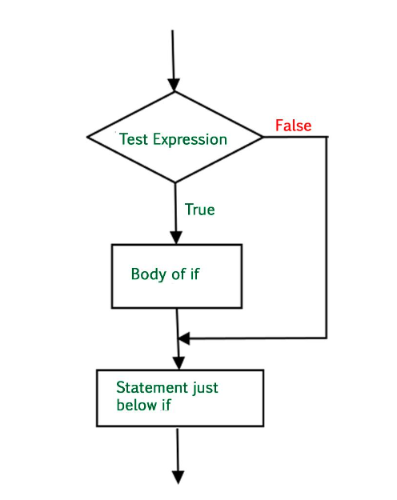

**Example of IF Statement :**

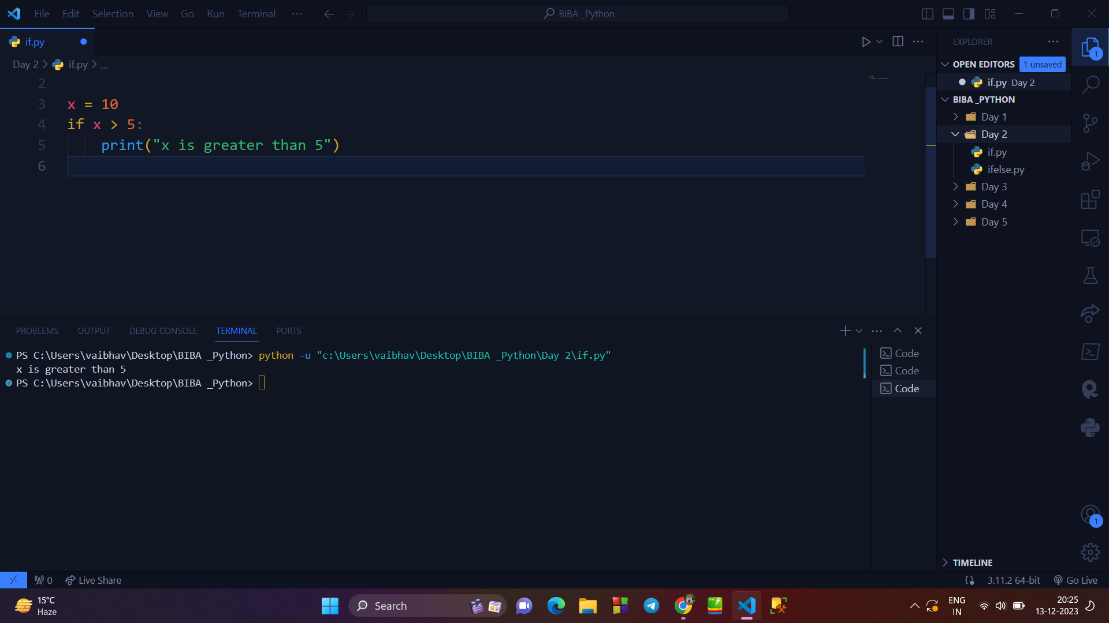

**→ IF ELSE STATEMENT :**

* It is also a conditional statement, if a particular condition is followed then code under if block will execute.
* But, if the condition doesn’t met, then code under else block will execute.
* It is better then normal IF statement.

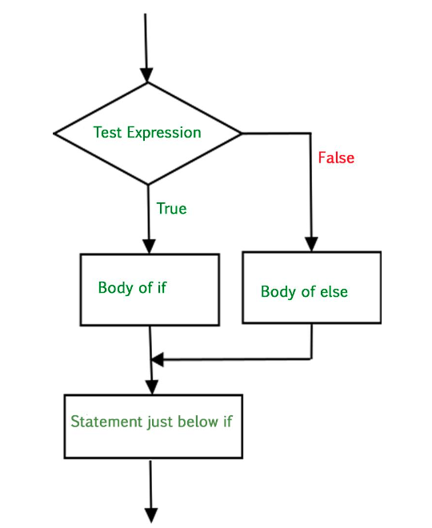

**Example :**

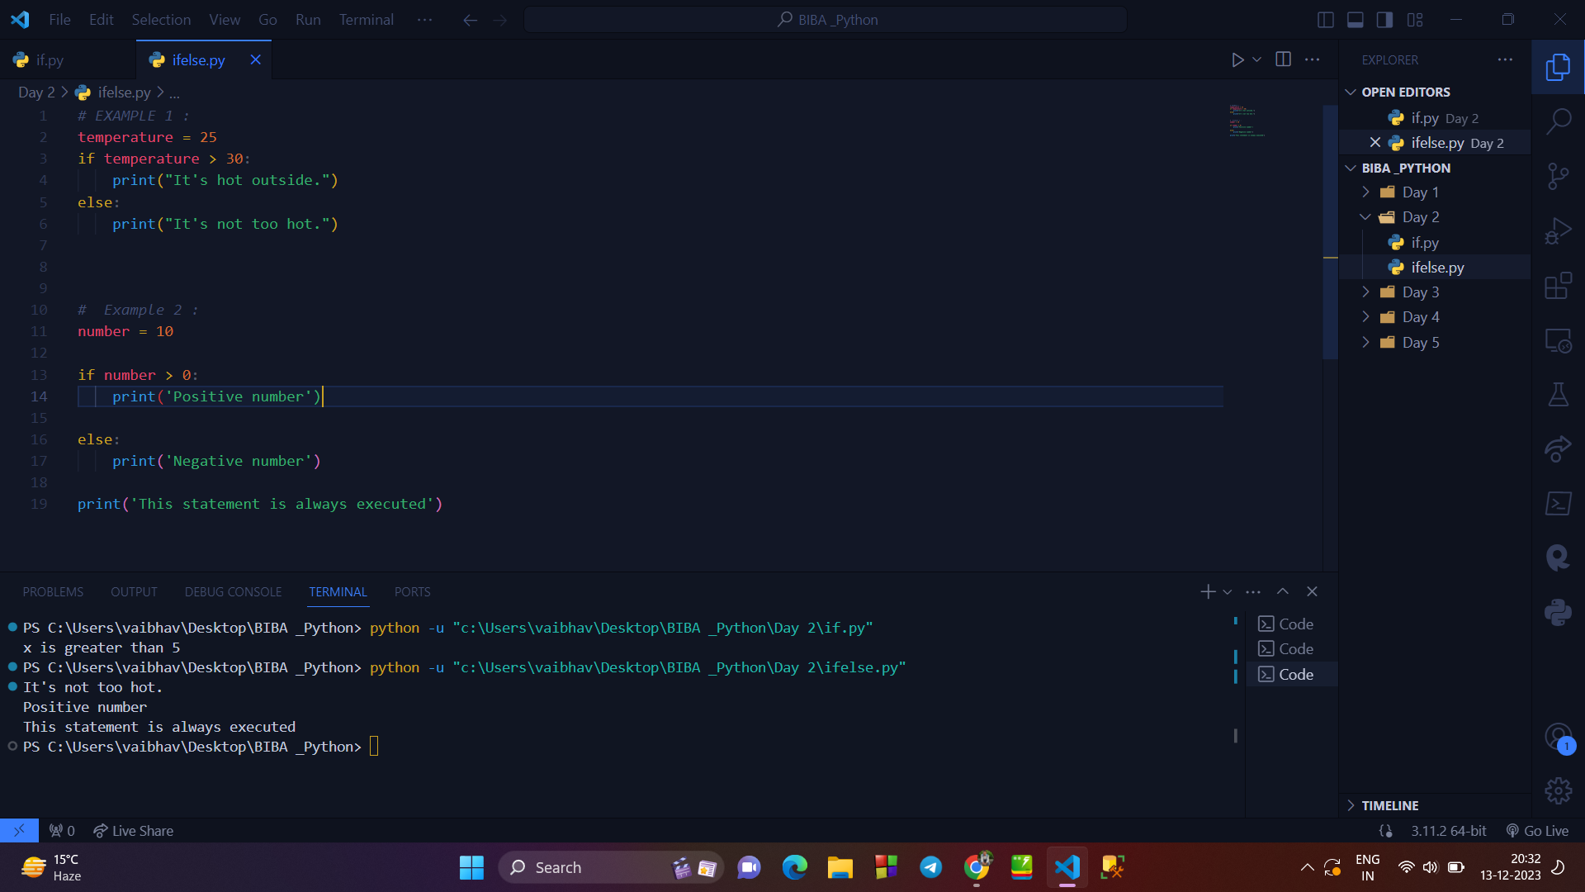

**→NESTED IF STATEMENT :**

* As we know about if statement, that it will execute when a condition is met.
* But, nested if statement is used when we have to check multiple condition one after another, means if one codition is true, then second is checked.
* Here, the hierarchy is maintained.

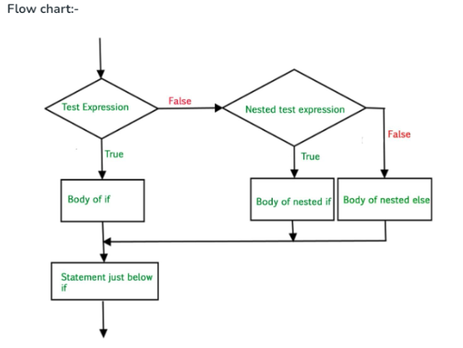

**Example :**

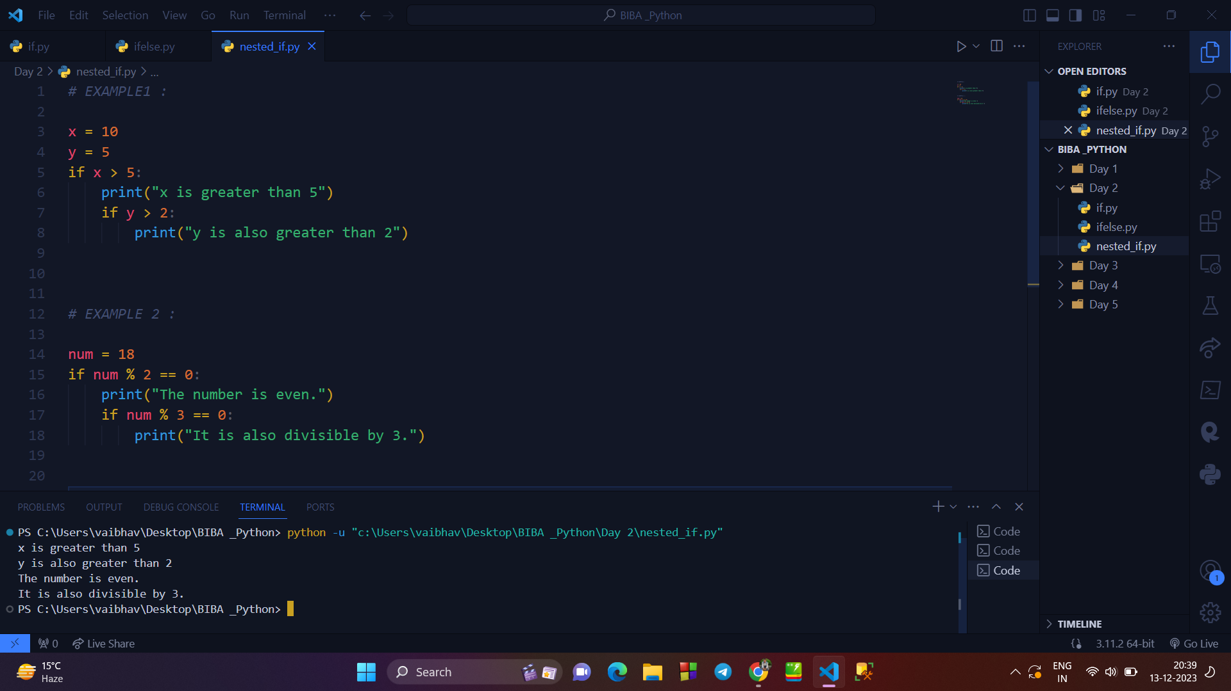

**→ IF - ELIF STATEMENT :**

* It is the extended version if else statement.
* When a condition is false, then it enters into the else block, so if we want to check further condition in the else block then we use elif block.
* It filters the output more n more.

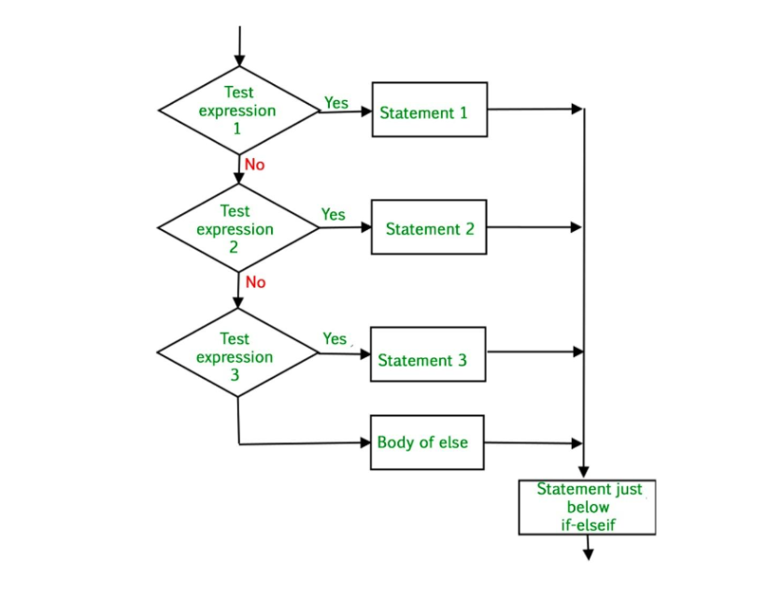

**Example :**

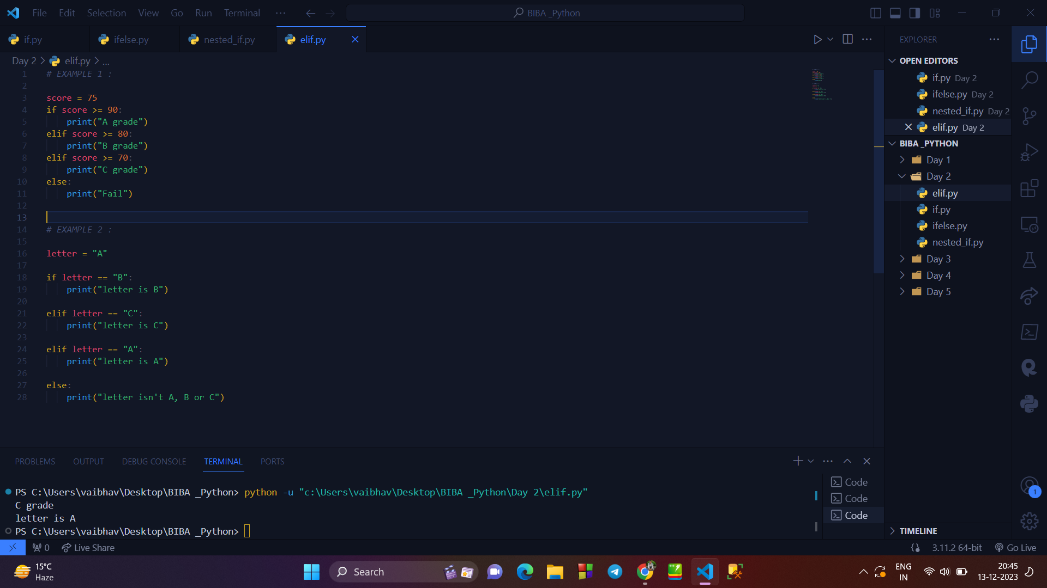

**→** **LOOPS IN PYTHON :**

* Loops are ued when we have to repeat a block of code multiple times, with or without changing the values.
* There are mainly : While Loop and For loop and rest are derived loops.

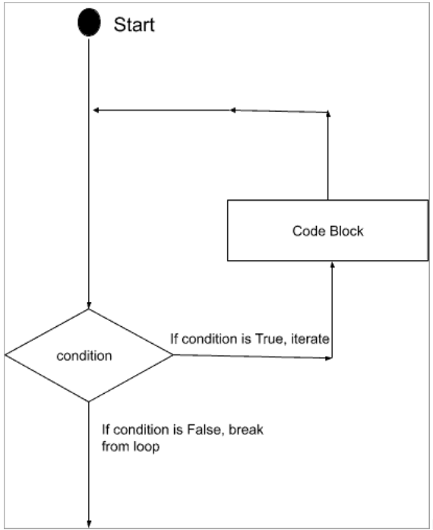

1. **While Loop :**
2. A while loop run the code until the condition written in it becomes false.
3. Its syntax is : WHILE(condition) :

Code

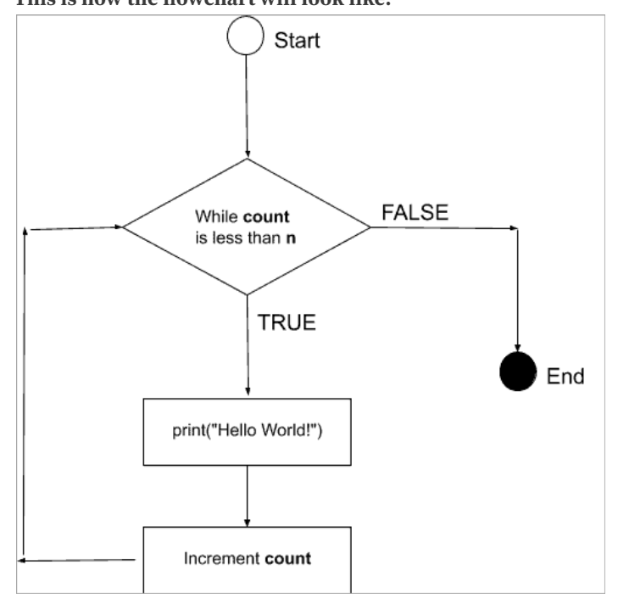

**Example :**

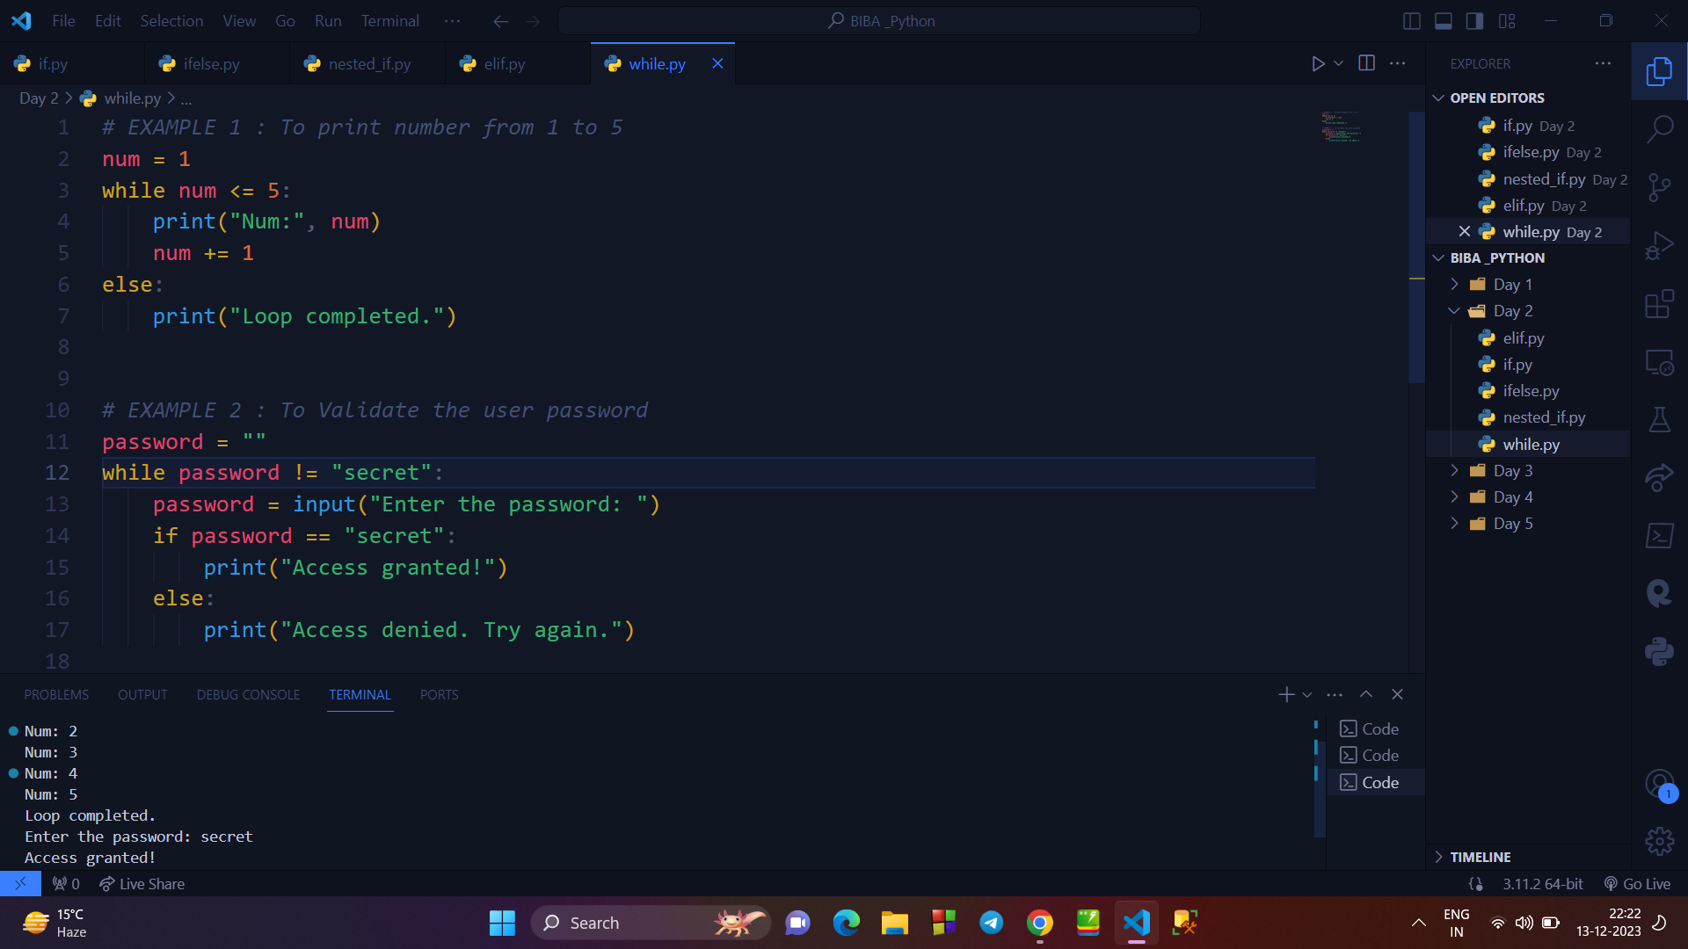

**2. FOR LOOP :**

* The for loop works well with iterable objects like lists, tuples, strings, etc. This way, we can step through these object’s items and manipulate their values based on our linking.
* The for loop is zero-indexed and has the following syntax.

*SYNTAX : for in n :*

*CODE;*

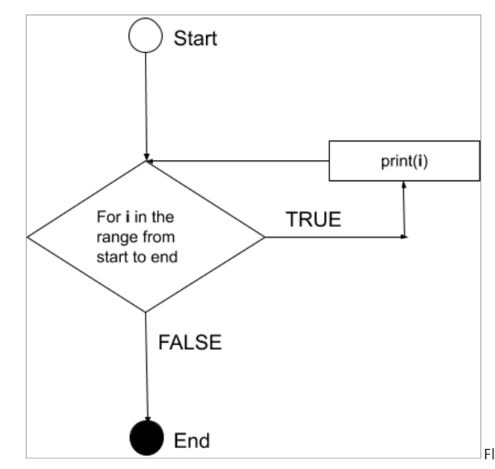

**EXAMPLE :**

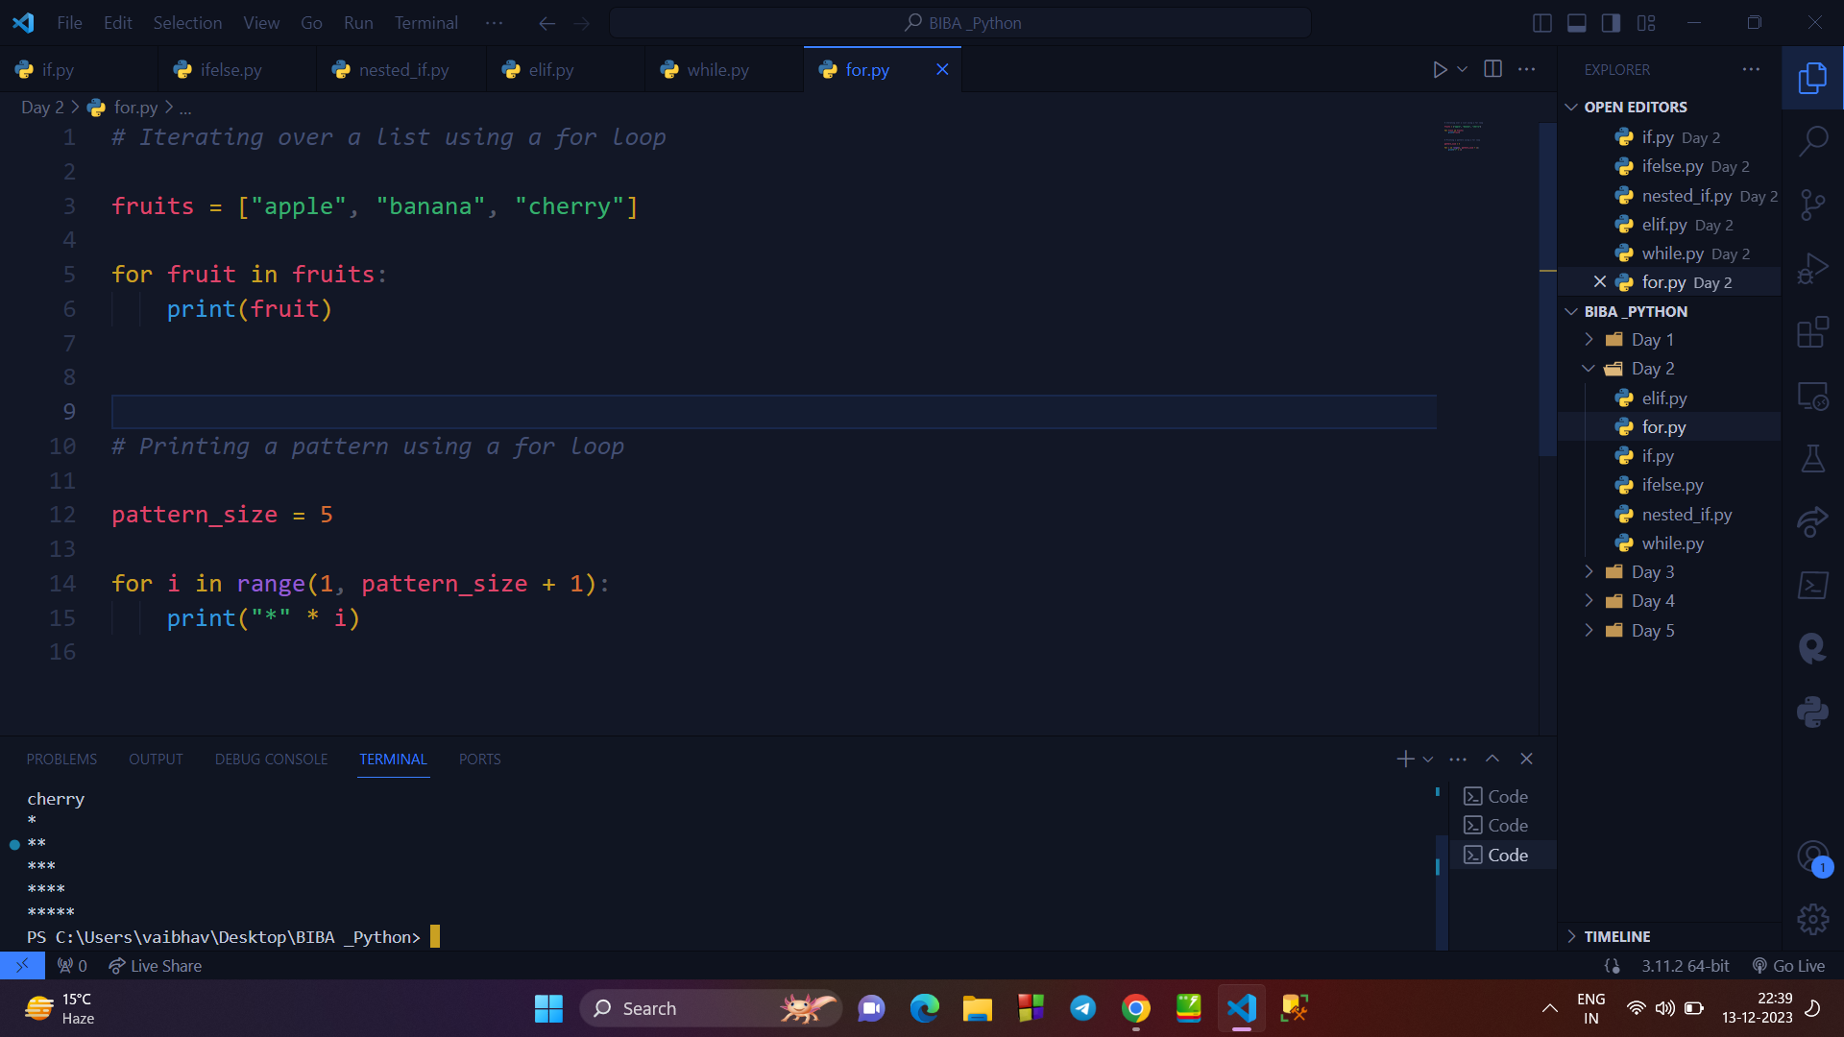

**3. NESTED WHILE LOOP :**

* When we use while loop inside a while loop, then it is called nested while loop.
* It helps us to simplify the complex tasks.
* Syntax of nested while loop is as follows :

while(condition):

Code

while(condition):

Code

**EXAMPLE :**

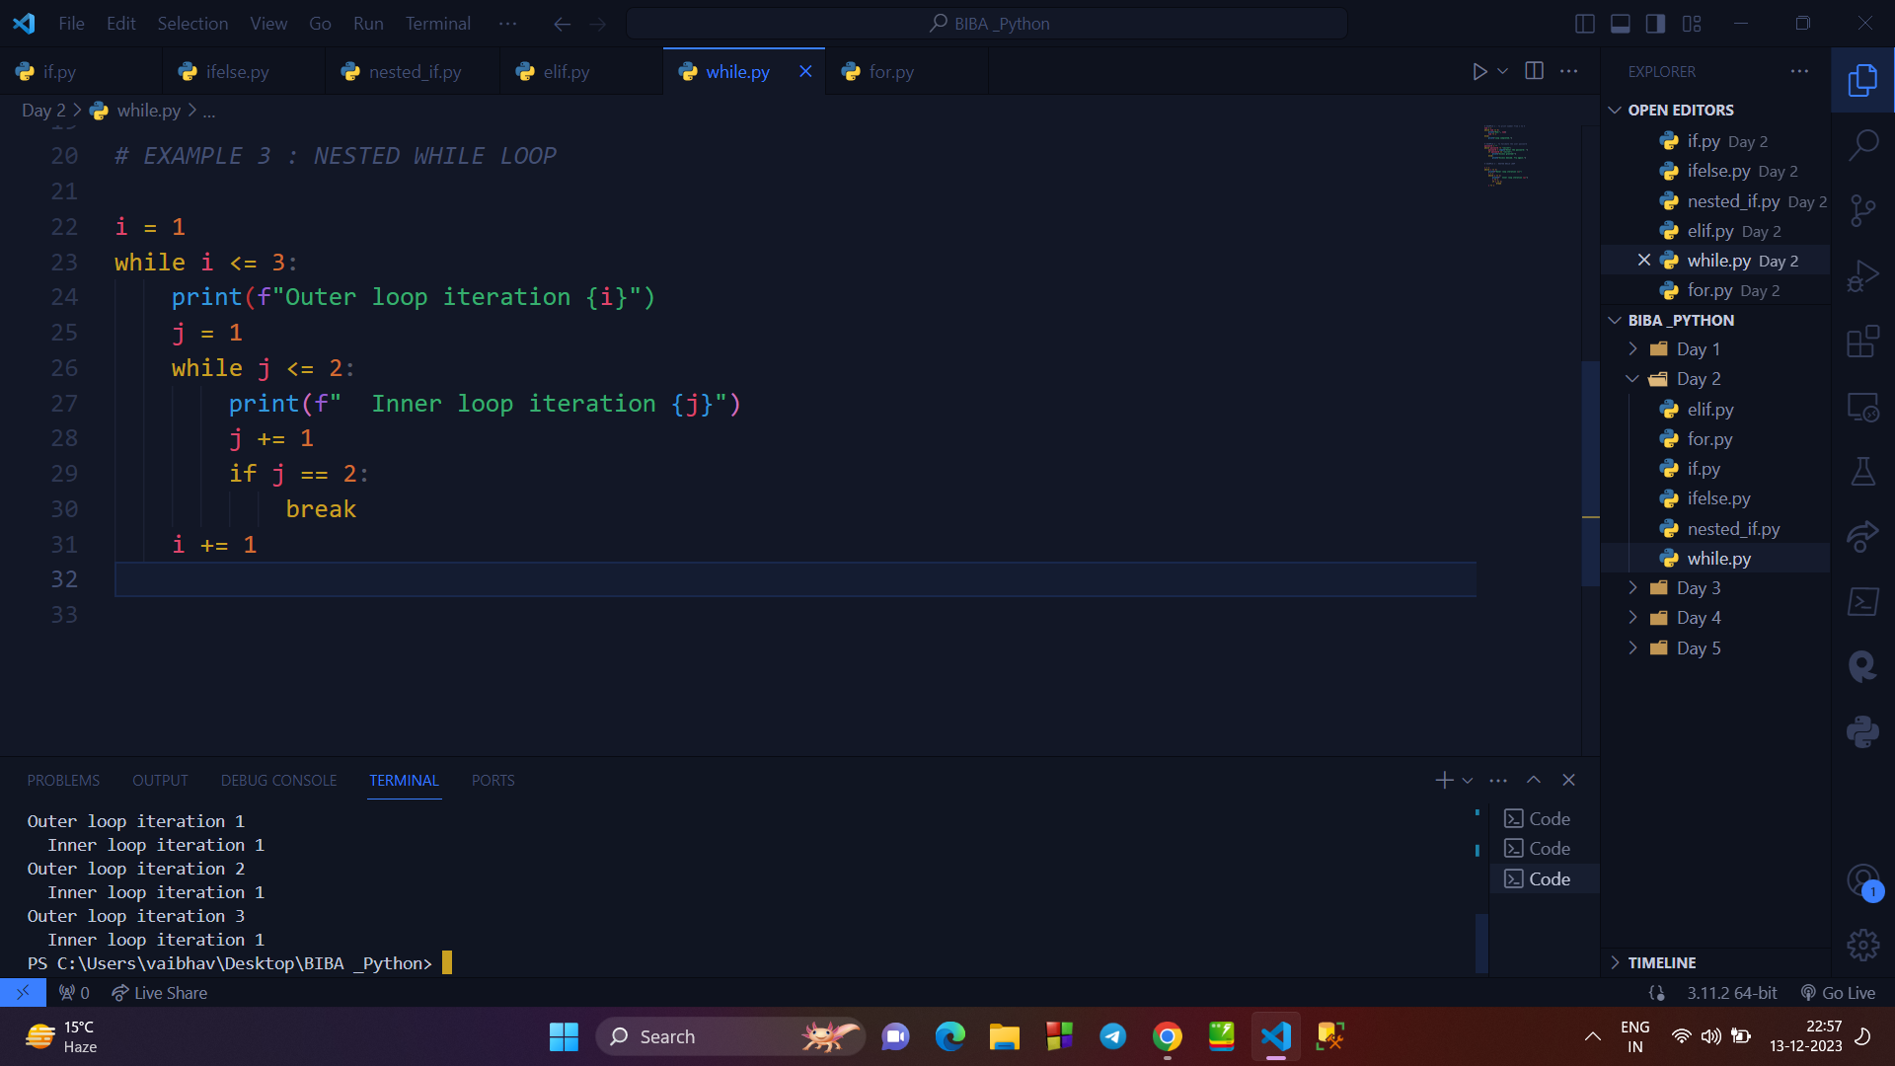

**4. NESTED FOR LOOP :**

* It is the advanced version of for loop, where we can use a for loop inside another for loop.
* Its syntax is as follows :

FOR __ in __ :

Code

FOR __ IN __ :

Code

**Example :**

